
CSD 212 DIGITAL IMAGE PROCESSING
Research Paper Implementation : LIME- Low Light Image Enhancement via Illumination Map Estimation

FACULTY MENTOR
DR. SAURABH JANARDAN SHIGWAN
Assistant Professor
Department of Computer Science and Engineering

Acknowledgement
I would like to express my sincere gratitude to all those who contributed to the successful completion of this project.
First and foremost, I am deeply thankful to Dr. Saurabh Janardan Shigwan, whose invaluable guidance, support, and encouragement were instrumental throughout the project. His insights and expertise helped shape the direction and quality of this work.
My appreciation goes to my friends and colleagues for their constant support, helpful discussions, and feedback, which greatly enriched this project.
Without the support and contribution of all these individuals, the successful completion of this project would not have been possible.

Introduction
Enhancing images captured under low-light conditions is essential for numerous computer vision tasks, including pedestrian detection and object recognition, where the accuracy heavily depends on the quality of input images. Traditional enhancement techniques such as histogram equalization and gamma correction often fall short—histogram equalization may introduce visual artifacts, while gamma correction overlooks the contextual relationships between neighbouring pixels, resulting in unnatural visual outputs. Inspired by Retinex theory, both single-scale and multi-scale Retinex methods have been proposed to address these limitations. However, these approaches can sometimes produce over-enhanced and visually unrealistic results. Recent advancements have shifted toward more refined solutions, including illumination map optimization using the Alternating Direction Method of Multipliers (ADMM) and adaptive histogram equalization strategies.

Methodology
The approach is based on the Retinex model, where the captured low-light image L is composed of the desired scene R and the illumination map T, as follows

where L and R are the captured image and the desired recovery, respectively. Furthermore, T represents the illumination map, and the operator ◦ means element-wise multiplication.
The enhanced image can be obtained by
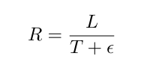
where the division is performed element-wise and ϵ is a small positive constant to avoid division by zero.
An initial estimate of the illumination map T(hat) for each pixel p, is obtained as per the following operation

This approach is designed to enhance the illumination of low-light images in a non-uniform manner, as opposed to uniformly increasing the overall brightness. It operates on the principle that the illumination at any given pixel can be approximated by the maximum value among its red, green, and blue (R, G, B) channel intensities. To refine the resulting illumination map—preserving the global structure of the image while simultaneously smoothing out local texture variations—the following optimization problem is formulated and solved.


where ∥·∥F is the Frobenius norm, α is the balancing coefficient, W is the weight matrix, ∥·∥1 is the ℓ1 norm, and ∇ denotes the gradient operator.
- Solving the Optimization Problem
As the ℓ1 norm is not differentiable, this problem can be solved by using the Alternating Direction Method of Multipliers (ADMM). Since both the terms in the objective function involve T, an auxiliary variable G is introduced for making the problem separable. Accordingly, ∇T = G is added as a constraint. As a result, the earlier optimization problem is equivalent to the following
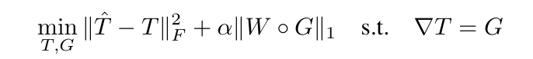
The augmented Lagrangian function for this problem can be formulated as
where ⟨·,·⟩ denotes the matrix inner product, µ denotes a positive penalty scalar, and Z is the Lagrangian multiplier. As per the augmented Lagrangian method, an iterative process of updating one variable at a time, keeping the other variables fixed, is followed, and each step has a simple closed-form solution.
The three sub problems are discussed below:
- T sub Problem- Collecting the T involved terms gives the problem as follows
this problem is classical least squares problem hence the solution can be computed through differentiating the above equation wrt T and setting it to zero.
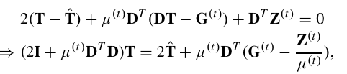
where I is the identity matrix with proper size. D contains Dh and Dv, which are the Toeplitz matrices from the discrete gradient operators with forward dif ference. For convenience, the operations DX and DTx represent reshape(Dx) and reshape(DTx), respectively, where x is the vectorized X, and reshape(·) stands for the operation of reshaping vectors back to their matrix forms. Directly calculating the inverse of 2I+µ(t)DTD is an intuitive way to accomplish this job. However, the matrix inverse is computationally expensive, especially for large matrices like DTD. Fortunately, by assuming circular boundary conditions, we can apply 2D FFT techniques on the above problem, which enables us to compute the solution fast. Consequently, we have
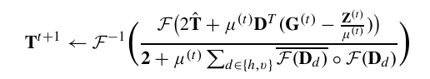
where F(·) is the 2D FFT operator, while F−1(·) and F(·) stand for the 2D inverse FFT and the complex conjugate of F(·), respectively. The division performs element-wise. In addition, 2 is the matrix with proper size, all the entries of which are 2.
- G sub Problem- Dropping the terms unrelated to G leads to the following optimization problem
The closed form solution can be easily obtained by performing the shrinkage operation
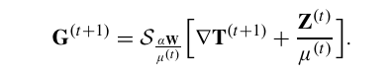
Sε>0[·] represents the shrinkage operator, the definition of which on scalars is: Sε[x] = sgn(x)max(|x|−ε,0). The extension of the shrinkage operator to vectors and matrices is to simply process data element-wise, say SA[X] performs the shrinkage on the elements of X with thresholds given by corresponding entries of A.
- Z and μ- The following equations are followed for updating Z and µ
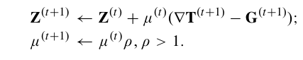
- Weighting Strategies
For the structure-aware refinement on the initial illumination map, the key is the design of W, such that W = reshape(w), where w is given by
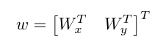
This strategy involves the use of relative total variation, so for each location, the weight is set as
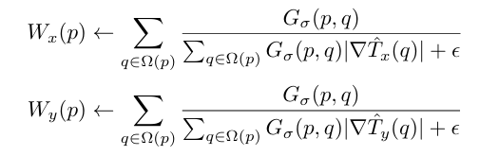
where p,q denote two pixels, Ω(p) denotes the region around pixel p and depends on the size of the kernel.
- Post Processing Techniques
After obtaining refined illumination map T we apply gamma correction to improve visual perception.

here the value of gamma that we have used is 0.8
- Denoising
It is observed that during the image enhancement process, noise—particularly in extremely low-light regions—tends to be amplified alongside the desired details. To mitigate this effect and further enhance visual quality, denoising becomes essential. In this work, a bilateral filter (BF) is employed—a nonlinear, edge-preserving smoothing technique well-suited for reducing noise while maintaining important structural details.

Results
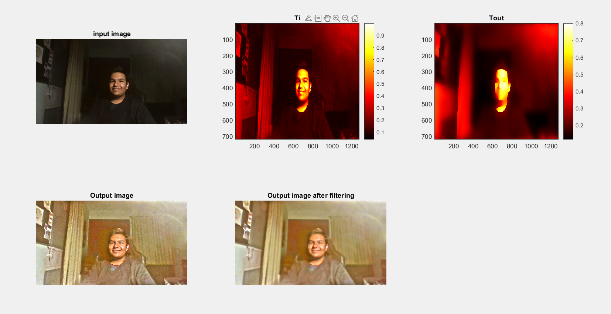
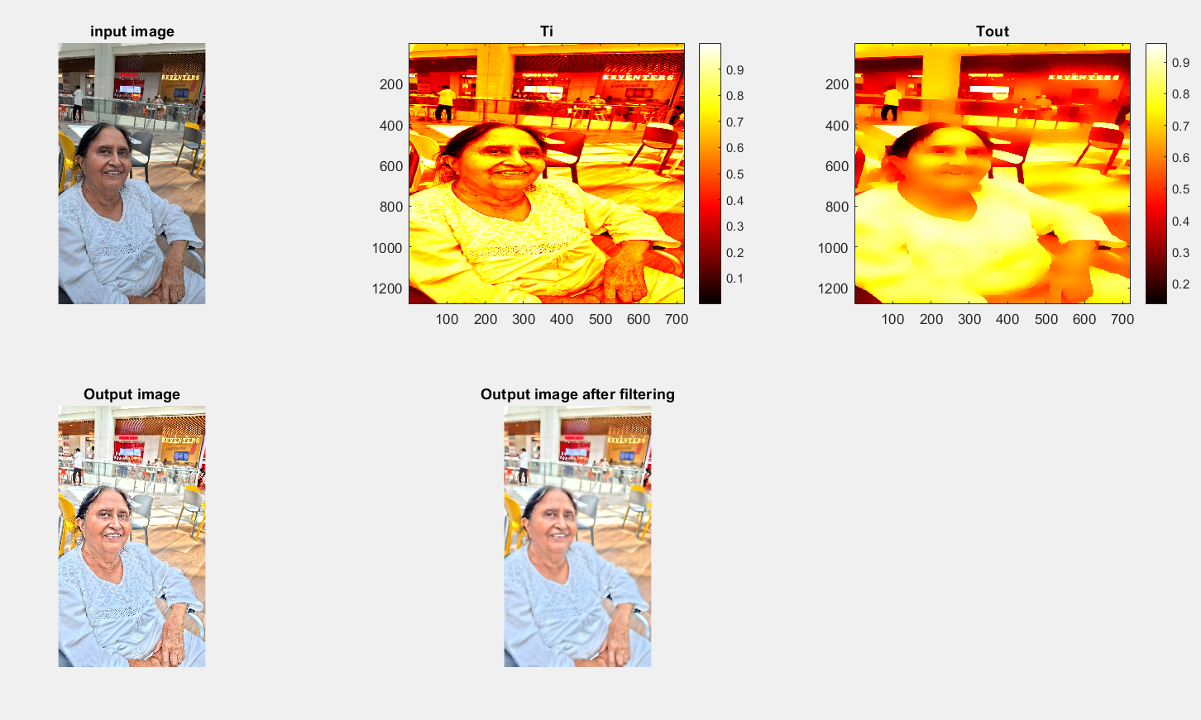
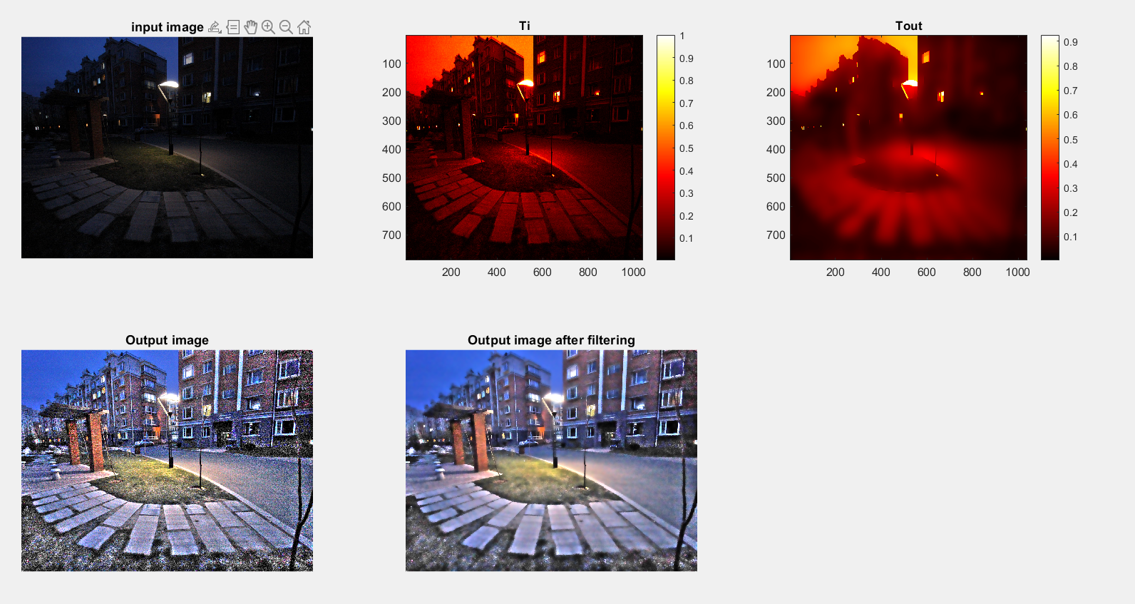

- The first image is our input image which is in low light surrounding
- The second image is our illumination map of the original image
- The third image is our estimated illumination map
- The fourth image is our output image
- The fifth image is the output image after bilateral filtering
Conclusion
In this study, we present a method for enhancing low-light images by estimating an illumination map. The results obtained are consistent with those reported in earlier foundational works, validating the effectiveness of our approach. Our objective is to offer a clearer and more accessible explanation of the core concepts involved. Future research could focus on developing techniques specifically aimed at enhancing low-light JPEG images, while also addressing typical compression artifacts such as blocking.

References
- X. Guo, Y. Li, and H. Ling, “LIME: Low-Light Image Enhancement via Illumination Map Estimation,” in IEEE Transactions on Image Processing, vol. 26, no. 2, pp. 982–993, Feb. 2017, doi: 10.1109/TIP.2016.2639450.

